13.43: Besides approximating the pendulum motion as SHM, assume that the angle
is sufficiently small that the length of the spring does not change while swinging in the
arc. Denote the angular frequency of the vertical motion as 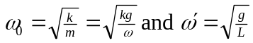
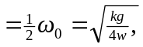 which is solved for 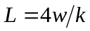. But L is the length of the stretched
spring; the unstretched length is

